
Afghan Ministry of Public Health 
Centers for
Disease Control

and Prevention

Maternal Mortality in Afghanistan:
Magnitude, Causes, Risk Factors and Preventability

Summary Findings
6 November 2002

STRICTLY EMBARGOED UNTIL 16:30 hrs GMT WEDNESDAY 6 NOVEMBER 2002

Linda Bartlett, MD, MHSc,
Sara Whitehead, MD, MPH,
Chadd Crouse, MSc.,
Sonya Bowens, MSc.,
US Centers for Disease Control and Prevention

Shairose Mawji, BN, MPH,
Denisa Ionete, MBBS,
Peter Salama, MBBS, MPH

UNICEF

Introduction

For over two decades, Afghanistan has been challenged by war, drought, famine and civil instability, which have decimated the infrastructure necessary for a healthy, stable and productive society. When a community is faced with such challenges, its women and children are often the most vulnerable. Women in Afghanistan have been particularly vulnerable to limited health care access because of several factors. These factors include restricted mobility and reduced numbers of female health care providers and of health care facilities that treat women. As a result, for Afghan women, the risk of death from complications of pregnancy or childbirth (maternal deaths) is very high.
To help prevent further maternal deaths, UNICEF Afghanistan requested technical assistance from CDC’s reproductive health program to conduct a study about maternal mortality. This report summarizes the results of this study, including the magnitude of maternal mortality, causes of maternal deaths, and an assessment of preventability. This study is a collaboration between the Afghan Ministry of Public Health, UNICEF and CDC. Findings from the study will be used to guide maternal health programs and services in Afghanistan.

Methods

From March to July, 2002, a women’s mortality survey was conducted in four provinces in Afghanistan. The study consisted of two stages: 1) identifying deaths among women of reproductive age ( 15-49 years old); and 2) investigating these women’s deaths.
The study was conducted in four provinces: Kabul, Laghman, Kandahar and Badakshan. These provinces were selected to represent a spectrum of urban to rural development, as an indicator of access to health care providers and facilities. In each province, one district was selected, and within this district villages were selected.
Mohammad lost his wife in labour, her baby undelivered. He walked from his home in remote Badakshan, in the snow, for 5 days trying to reach a health care worker. There is no means of transportation across the mountains here in the winter time. When Mohammad finally reached the only village where there were limited medical services, the only health care worker was already attending to another serious patient and could not leave. Mohammad returned to his village, only to receive news that his wife and her unborn child had died. Their three year old daughter is now left without a mother.
For the first stage of the study, death identification, all families in the randomly selected villages were visited by Afghan female interviewers, trained by UNICEF. These interviewers asked the families about births and deaths in the family during the three-year study period (April 1999 to March 2002). About 13,000 families were visited, providing information on over 85,000 individuals.
For the second stage of the study, families of women who died were interviewed by one of a team of physicians and midwives from CDC and UNICEF using a technique called verbal autopsy. In a verbal autopsy, the interviewer asks questions about the symptoms a woman experienced around the time of her death so that the cause of death can be determined. In addition, the interviewer asked questions about risk factors for death, barriers to health care access, potential preventability of the death, and about the survival of the children of women who had died. We determined whether a woman’s death could be prevented by reviewing the circumstances of each death, its cause, the quality and availability of health care services, the family’s perception of preventability and the interviewer’s perceptions of barriers to health care.

We used a framework to assess three categories of barriers to health care access. At the first level, the barriers included failure to recognize the existence of a problem or deciding not to seek health care either because the pregnant woman, her family, or her home birth attendants did not know the normal processes or complications of pregnancy, labor, delivery, or the postpartum period; and a lack of decision-making ability or empowerment once a problem had been recognized. Second-level barriers included not reaching health care once a decision had been made to seek care either because it was not affordable or because emergency transport was not available. Third-level barriers included not receiving quality and timely treatment.
Torab lives with his four daughters in a remote village in Badakshan. Their mother died in childbirth due to obstructed labour. She was in labour for two days but all those around her assumed that the birth would be a normal one. Eventually Torab decided to seek help from a health care worker and it became apparent that the baby was in lying sideways in the womb. There was no way for Torab’s wife to reach the nearest city – four days away by horseback – for an operation. The family called the Mullah and prayed for her. She and her baby both died two days later, the baby still undelivered.

Results
Mullah lost his first wife in childbirth and one month prior to the maternal mortality survey, he lost his second wife in childbirth as well. He explains how difficult life is for them, there is no access to health care services, “It’s too far and expensive to go to the nearest main town”, he explains “and in the winter time, we have no way to travel”. His first wife died of Eclampsia and his second wife from post-partum hemorrhage. He says, ”It is up to Allah first to help us”’ and then the doctors can help.

Number of Deaths

There were 356 families that identified a woman of reproductive age who had died during the study period. Of these deaths, 295 (83 per cent) were investigated through verbal autopsy interviews. In most of the cases where we did not investigate a reported death, it was because of security issues or because the family involved had moved and was not available for interviews.
Key Findings

- Using findings from this study, we estimate that the maternal mortality ratio (MMR: maternal deaths per 100,000 live births) in Afghanistan is 1600 per 100,000 live births (95% confidence interval [CI] = 1100-2000.) This is one of the highest levels of maternal mortality reported globally. However, important differences exist between urban and rural areas in our study: in Kabul, the MMR was 400 (95% CI 200-600); Laghman was 800 (400 -1100); Kandahar was 2200 (1150 -3000); Badakshan was 6500 (5000-8000). The MMR in Badakshan is the highest ever reported globally, highlighting not only the importance of this health issue in Afghanistan, but also that great variation in health exists within Afghanistan.
- Furthermore, we estimate that among women of childbearing age who die in Afghanistan, almost half (48%; 95% CI= 39-58 %) will die from complications of pregnancy or childbirth. These figures also differ greatly by region: the proportion of women who died of maternal causes ranged from 16 per cent in Kabul, where at least one maternity hospital was functional, to 64 per cent in Badakshan, where health care access was profoundly limited. This proportion for Badakshan is the also highest proportion of deaths due to maternal mortality reported in the world.

- In our study population, if a newborn’s mother died of maternal causes, the baby had only one chance in four of living until its first birthday. Most of these infants died in the first month of life from acute malnutrition due to lack of breast milk.

- Most (about 70 per cent) of the women who died experienced barriers at all three levels.

- Among the women who died in this study, about 87 per cent of maternal deaths were considered preventable.

- About half of the women in Kabul received prenatal care and had their babies delivered by a skilled attendant. The proportion of women with access to health care was substantially lower in the other three provinces. For example, no women in either Kandahar or Badakshan were attended by a skilled attendant during childbirth.

- Consistent with global reports, the most frequent cause of maternal death was hemorrhage. The second leading cause was obstructed labor, which means that most of these women died undelivered. However, notably, in Badakshan, more women died of obstructed labor than from hemorrhage. Consistent with our finding of no access to health care, most of these deaths could have been prevented by operative delivery.
- Only 5 per cent of women on our study could read or write and only 36 per cent of the families interviewed owned a radio.

Conclusions
Maternal mortality in Afghanistan is the leading cause of death among women of reproductive age and varies greatly by region. Levels found in Afghanistan overall are among the highest in the world, and in Badakshan, is the highest ever documented. Most women did not access a doctor or physician to help with the birth, an important way to prevent maternal deaths. In addition, the poor survival rate of the newborns of the women who died shows the impact of a maternal death on these families, already living in a war-torn and stressful environment. Many of the deaths are preventable with basic health care services, yet most women were reported to have encountered barriers to health care at all three levels, indicating the need for comprehensive program development. Public health resources and capacity building in Afghanistan must highly prioritize maternal and child care in order to promote family health and, ultimately, the development of a healthy society.
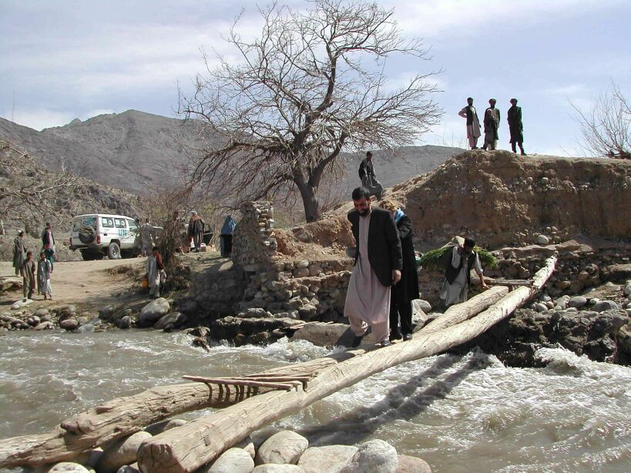Footbridge in Laghman Province – the only way of crossing from one side of the river to the other. The health centre is located on one side of the river , the hospital on the other. Crossing this bridge alone is difficult enough; doing so whilst carrying a stretcher is a life-threatening experience. Transportation remains one of the key problems to accessing emergency obstetric care facilities all over Afghanistan.

Recommendations include increasing access to skilled prenatal care to teach women about healthy pregnancies and deliveries; screening for preventable causes of maternal complications, such as pre-eclampsia, anemia, and malaria; and increasing access to skilled birth attendants (physicians and midwives), while improving general health services. Education programs to teach families about healthy pregnancies and other basic health messages such as clean food and water will need to be creatively distributed because of the low literacy levels and small number of families with radios.

The survival of mothers is an issue of extreme health importance in Afghanistan and improving survival is a great challenge, particularly in rural areas where almost no health system exists. However, motivation is very strong in this family-oriented culture, which will be a tremendous resource to the humanitarian aid community and to governments and other organizations as they mobilize to address the complex, long-term issues involved in assuring quality health to all Afghan families.
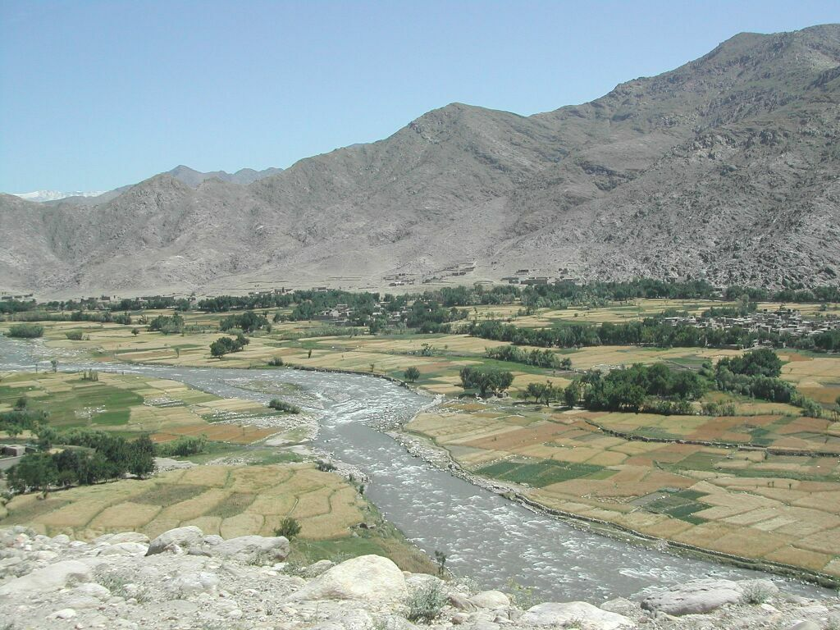

Alishing valley in Laghman province in Eastern Afghanistan. Only one foot bridge is available to cross from one valley to the other, making it very difficult to transport emergency cases to the hospital which is located on one side of the valley. The mountains in the background, where many villages are located, are also only accessible by walking and by donkey - very few families own horses here.

***
The names of individuals mentioned in sidebars have been changed to respect their privacy.

